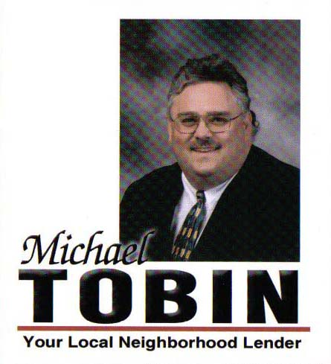

Michael Tobin Offers You:
- Superior Knowledge of Conventional, VA/FHA and non-conforming loans
- Expert Product Knowledge
- Excellent Communication Skills
- A Skillful and Effective Support Team
- An Award Winning Producer
- Exceptional Personal Service and Commitment to Your Success

What else can you expect when working with Michael Tobin?

INTEGRITY
- Total honesty is the key to all good relationships and Michael is committed to being 100% honest.

HONESTY
- Michael takes pride in his reputation as an honest, straightforward professional. Michael knows that you need to hear the truth about your loan!

STAYING IN TOUCH
- Michael will keep in constant communication with you throughout every step of financing your home.

SERVICE
- Many people find the process of funding real estate time-consuming, expensive and exhausting. But working with the right person can make all the difference! Michael makes certain buyers get a loan that feels right for them.

Contact us today! Cell 314-503-7373 Fax 636-387-8734 E-mail stlgateway@aol.com

